1. Open console.redhat.com

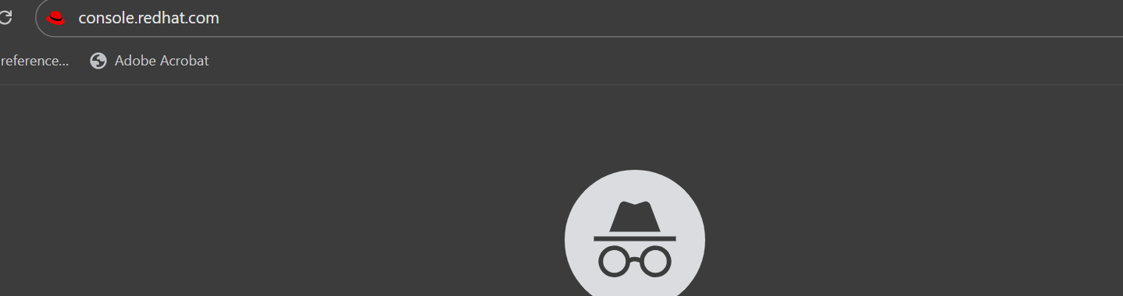

1. Login with Github (Please use personal github account)

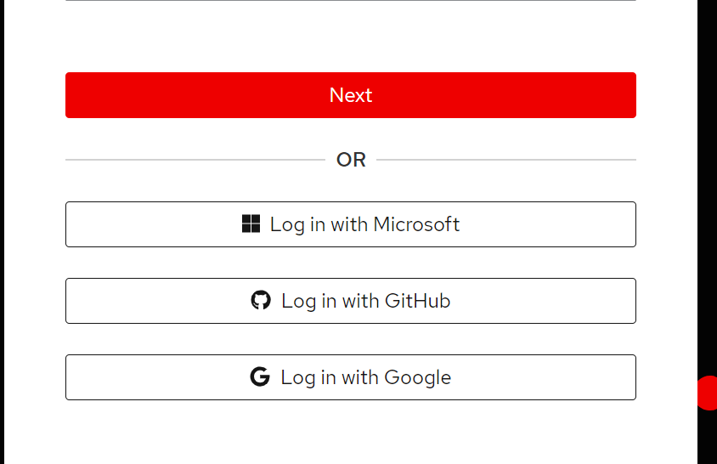

1. Authorize Redhat sso

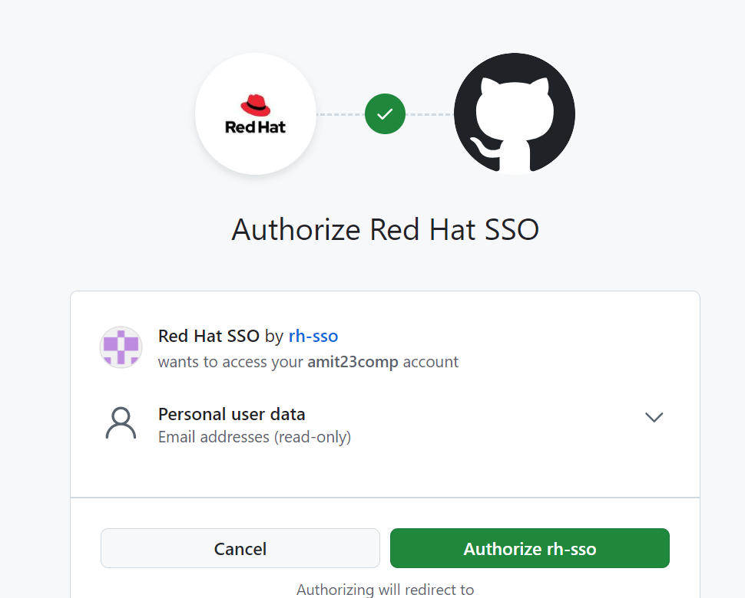

Provide your personal details and correct mobile number

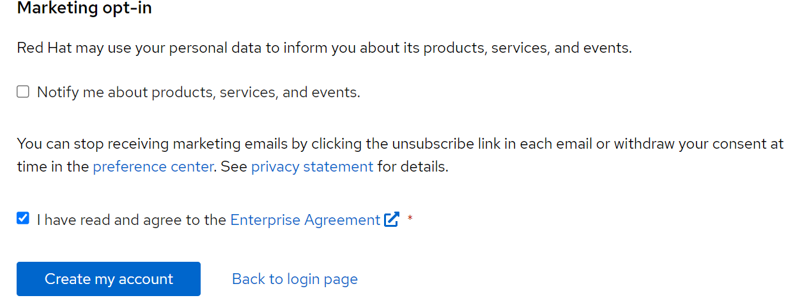

Select service redhat openshift

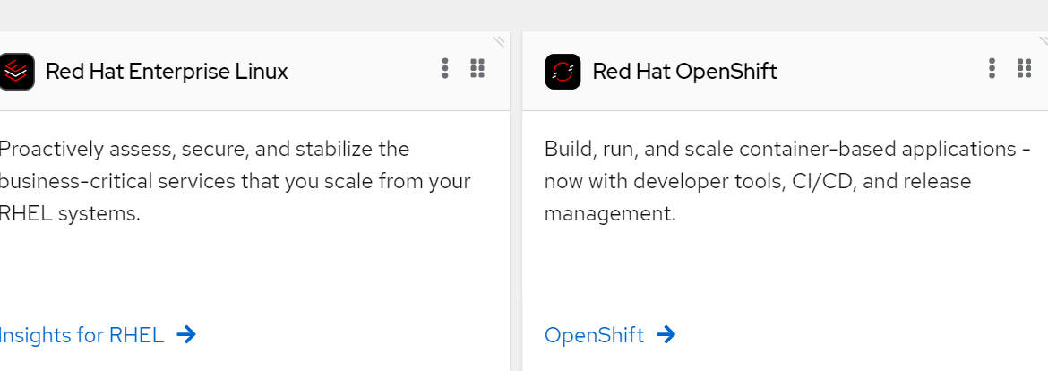

Left hand side pane, check for developer sandbox

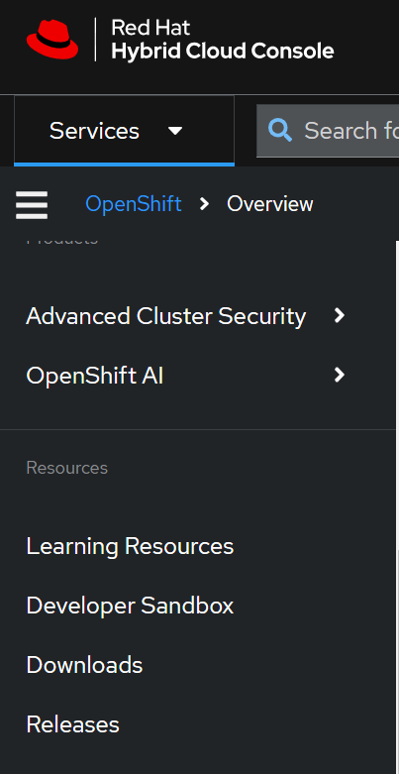

Click on Get Started

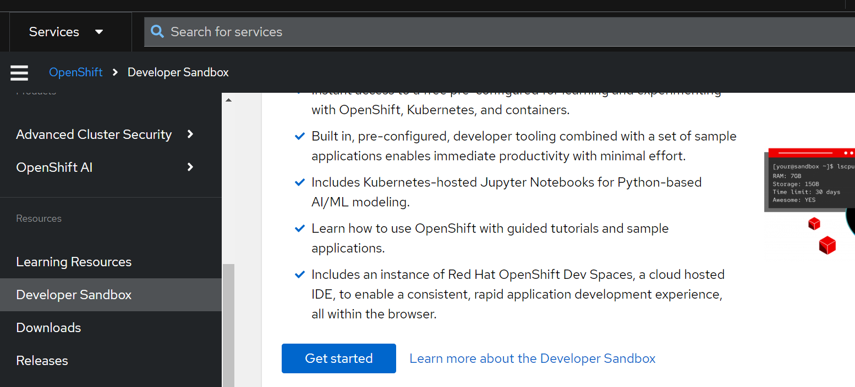

Click on Redhat openshift Lanuch

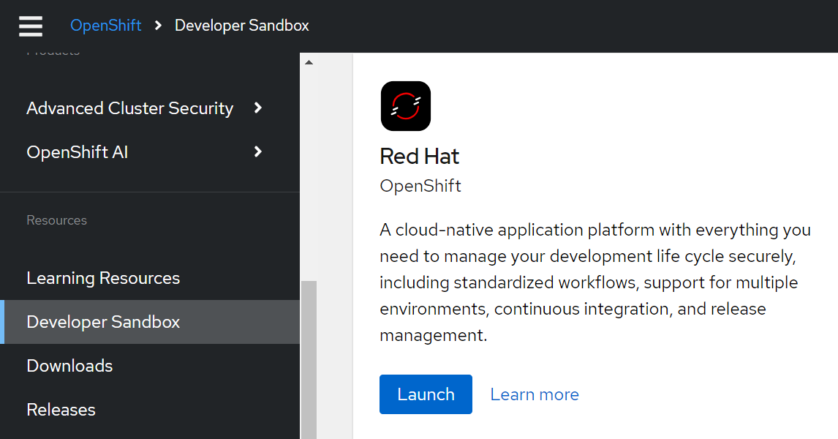

Click on DevSandbox

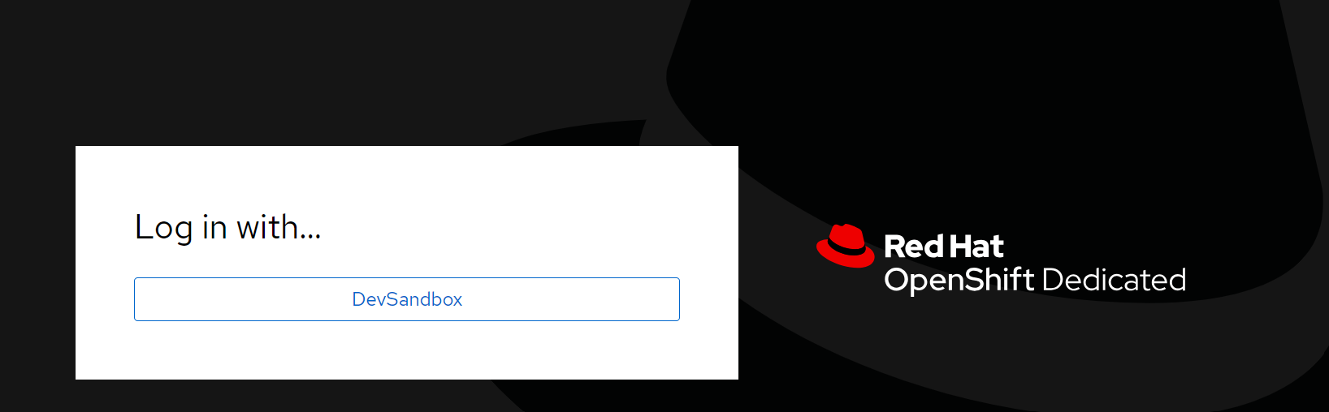

It may ask for relogin (please do the relogin)

After login left hand side you will find dropdown Developer, Select Administrator

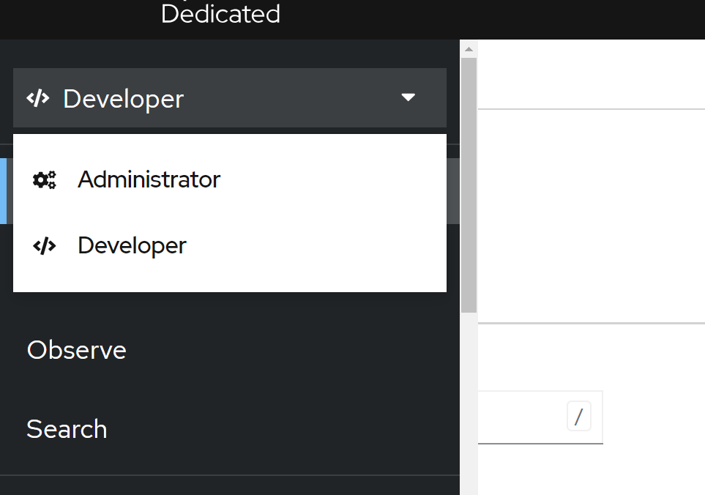

Select the icon

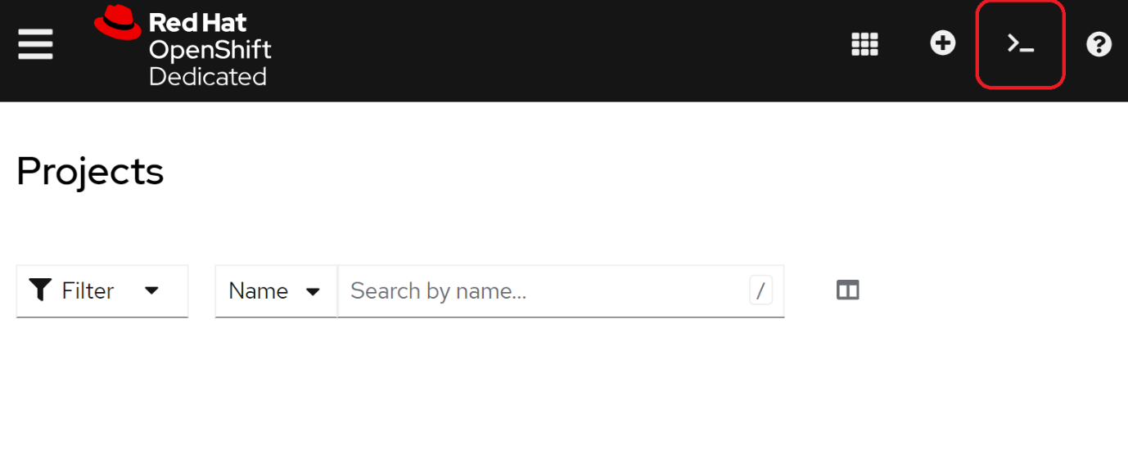

Select your project and click on start

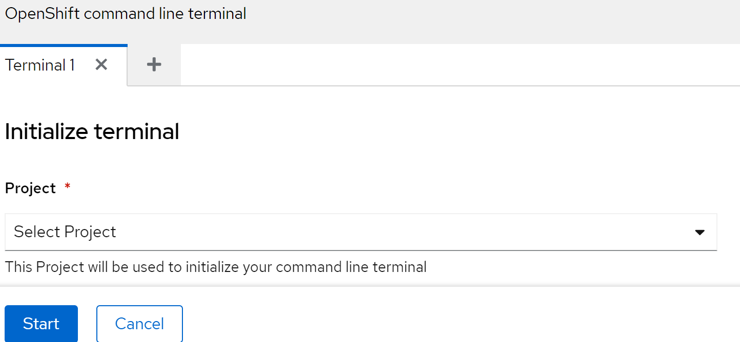

Open the cli

